Coronavirus disease 2019 (COVID-19)
Situation Report – 79

Data as received by WHO from national authorities by 10:00 CET, 8 April 2020

HIGHLIGHTS
- One new country/territory/area reported cases of COVID-19 in the past 24 hours: Saint Pierre and Miquelon.

- WHO has published a guidance document on the rational use of personal protective equipment (PPE) in healthcare and home care settings, as well as during the handling of cargo. The document assesses the current disruption in the global supply chain and outlines considerations for decision-making during severe shortages of PPE. For more details, please see here.

- WHO has listed the first two diagnostic tests for emergency use during the COVID-19 pandemic. The move should help increase access to quality-assured, accurate tests for the disease. It also means that the tests can now be supplied by the United Nations and other procurement agencies supporting the COVID- 19 response. For more information, please see here.

- WHO has published a guideline on food safety, ‘COVID-19 and Food Safety:
Guidance for Food Businesses’. For more details, please see here.

- The Global Health Cluster, which WHO leads, has been supporting 29 countries to implement the Global Humanitarian Response Plan for COVID-19. This includes addressing newly-emerging needs and preserving the existing humanitarian health actions and commitments of the Humanitarian Response Plans for 2020. For more information on partner coordination, please see ‘Subject in Focus’.
SITUATION IN NUMBERS
total (new) cases in last 24 hours

Globally
1 353 361 confirmed (73 639)
79 235 deaths (6695)

European Region
720 219 confirmed (33 881)
57 639 deaths (4904)

Region of the Americas
417 416 confirmed (33 174)
12 597 deaths (1500)

Western Pacific Region
114 667 confirmed (1026)
3922 deaths (30)

Eastern Mediterranean Region
81 993 confirmed (3428)
4314 deaths (165)

South-East Asia Region
10 707 confirmed (1575)
426 deaths (64)

African Region
7647 confirmed (555)
326 deaths (32)

WHO RISK ASSESSMENT
Global Level Very High

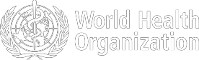

Figure 1. Countries, territories or areas with reported confirmed cases of COVID-19, 8 April 2020

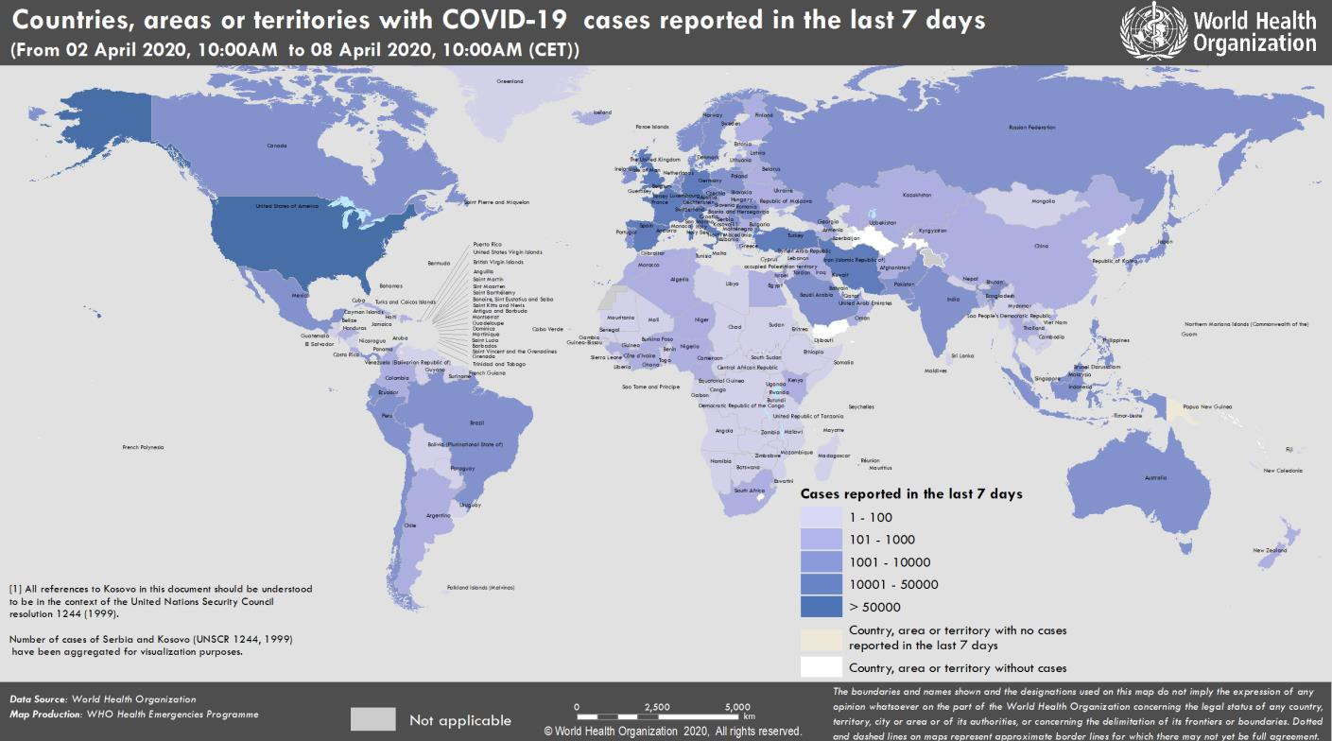

SUBJECT IN FOCUS: Partner Coordination

Global Health Cluster

- The Global Health Cluster, which WHO leads, has been supporting 29 countries to implement the Global Humanitarian Response Plan for COVID-19. This includes addressing newly-emerging needs and preserving the existing humanitarian health actions and commitments of the Humanitarian Response Plans for 2020.
- In collaboration with the Gender-Based Violence Area of Responsibility (GBV AoR), a webinar was held on “Ensuring continuity of essential health services for survivors of GBV during COVID-19”. The GBV AoR is the global level forum for coordination and collaboration on GBV prevention and response in humanitarian settings.

Emergency Medical Teams (EMT) Initiative

- Over 100 Emergency Medical Teams (EMT) and focal points worldwide are working closely with the EMT Secretariat, and are continuously engaging in monitoring, guiding, and facilitating national and international COVID-19 response operations.
- As of 5 April, five international EMTs have been deployed to eight countries. Twenty-nine EMTs are supporting and reinforcing local national health systems across all regions. EMTs are also involved in discussions to strengthen capacity and support to countries in Africa. In addition, WHO is working with EMTs worldwide to identify technical experts and coordinators who can support integrated public health and clinical teams.
- WHO has finalised technical guidance on COVID-19 community facilities and treatment centers, pre-hospital emergency medical services recommendations, and recommendations for medical surge capacity and deployments of EMTs. A modular training package on COVID-19 is currently being developed for the EMT workforce.

Global Outbreak Alert and Response Network (GOARN) deployments and partnership activities

- WHO has deployed 59 experts from 27 partner institutions and technical networks to support countries. Twenty- two partners of the GOARN Capacity Development Network are meeting this week to strengthen coordination of training and capacity building activities.
- The International Federation of Red Cross and Red Crescent Societies (IFRC), UNICEF, and WHO are supporting Risk Communications and Community Engagement (RCCE) with a special focus on highly vulnerable populations, and integration of humanitarian partners to support social distancing solutions amongst migrants and in camp settings. This week’s focus is mask guidance among the general population, and in the event of easing of movement restrictions. The partnership is also looking at social science and community insights, including perception surveys and community engagement during lockdowns, to explore guidance, operational challenges and lessons learnt from ongoing experience.

Global Outbreak Alert and Response Network (GOARN) research activities

GOARN research activities include:

- Creating a repository of RCCE data collection tools to aid researchers and public health organizations to roll out rapid assessments in their communities of interest. If you would like to contribute, please contact Dr. Jeni Stolow at jstolow@tulane.edu.
- Coordination with Field Epidemiology Training Programmes, regional and global networks, and alumni networks, on exchange of protocols and tools for investigations and response.
- Coordination of global partners to support the WHO COVID-19 Research Innovation and Research Roadmap Social Science Working Group. Ongoing research includes psychosocial impact of community-based interventions, psychosocial assessment of healthcare workers (HCWs), HCW readiness for COVID-19 infection prevention and control, home-based care delivery, and decision-making for palliative care.
- Knowledge management of COVID-19-related information, including identification of research findings and channeling of findings to appropriate audiences; and development of a process for rapid literature searches/reviews. For information on the above activities, please contact Dr. Lina Moses at lmoses2@tulane.edu.

Critical Supply Chains and Goods

- UNICEF is leading joint UN efforts to access substantial quantities of critical items such as PPE and supplies for intensive care, through a joint tender where the overall allocation principles of supplies will be guided by WHO and the Supply Chain Inter-Agency Coordination Cell. The detailed process is under development.
SURVEILLANCE

Table 1. Countries, territories or areas with reported laboratory-confirmed COVID-19 cases and deaths. Data as of 8 April 2020*
Reporting Country/ Territory/Area† | Total confirmed  ‡ cases |  | Total confirmed new cases | Total deaths | Total new deaths | Transmission classification§ | Days since last reported case
Western Pacific Region
China |  | 83157 | 86 | 3342 | 2 | Local transmission | 0
Republic of Korea |  | 10384 | 53 | 200 | 8 | Local transmission | 0
Australia |  | 5956 | 112 | 45 | 3 | Local transmission | 0
Japan |  | 4257 | 351 | 81 | 1 | Local transmission | 0
Malaysia |  | 3963 | 170 | 63 | 1 | Local transmission | 0
Philippines |  | 3764 | 104 | 177 | 14 | Local transmission | 0
Singapore |  | 1481 | 106 | 6 | 0 | Local transmission | 0
New Zealand |  | 969 | 26 | 1 | 0 | Local transmission | 0
Viet Nam |  | 249 | 4 | 0 | 0 | Local transmission | 0
Brunei Darussalam |  | 135 | 0 | 1 | 0 | Local transmission | 3
Cambodia |  | 115 | 0 | 0 | 0 | Local transmission | 1
Fiji |  | 15 | 1 | 0 | 0 | Local transmission | 0
Mongolia |  | 15 | 0 | 0 | 0 | Imported cases only | 1
Lao People's Democratic Republic |  | 12 | 0 | 0 | 0 | Local transmission | 1
Papua New Guinea |  | 1 | 0 | 0 | 0 | Imported cases only | 18
Territories**
Guam |  | 121 | 8 | 4 | 0 | Local transmission | 0
French Polynesia |  | 47 | 5 | 0 | 0 | Local transmission | 0
New Caledonia |  | 18 | 0 | 0 | 0 | Local transmission | 5
Northern Mariana Islands (Commonwealth of the) |  | 8 | 0 | 2 | 1 | Local transmission | 5
European Region
Spain |  | 140510 | 5478 | 13798 | 743 | Local transmission | 0
Italy |  | 135586 | 3039 | 17129 | 604 | Local transmission | 0
Germany |  | 103228 | 4003 | 1861 | 254 | Local transmission | 0
France |  | 77226 | 3738 | 10313 | 1417 | Local transmission | 0
The United Kingdom |  | 55246 | 3634 | 6159 | 786 | Local transmission | 0
Turkey |  | 34109 | 3892 | 725 | 76 | Local transmission | 0
Belgium |  | 22194 | 1380 | 2035 | 403 | Local transmission | 0
Switzerland |  | 22164 | 590 | 641 | 0 | Local transmission | 0
Netherlands |  | 19580 | 777 | 2101 | 234 | Local transmission | 0
Austria |  | 12640 | 343 | 243 | 23 | Local transmission | 0
Portugal |  | 12442 | 712 | 345 | 34 | Local transmission | 0
Israel |  | 9404 | 793 | 71 | 19 | Local transmission | 0
Sweden |  | 7693 | 487 | 591 | 114 | Local transmission | 0
Russian Federation |  | 7497 | 1154 | 58 | 11 | Local transmission | 0
Norway |  | 5863 | 108 | 69 | 10 | Local transmission | 0
Ireland |  | 5709 | 345 | 210 | 36 | Local transmission | 0

Denmark | 5071 | 390 | 203 | 16 | Local transmission | 0
Czechia | 5017 | 195 | 88 | 10 | Local transmission | 0
Poland | 4848 | 435 | 129 | 22 | Local transmission | 0
Romania | 4417 | 360 | 182 | 25 | Local transmission | 0
Luxembourg | 2970 | 127 | 44 | 3 | Local transmission | 0
Serbia | 2447 | 247 | 61 | 3 | Local transmission | 0
Finland | 2308 | 132 | 34 | 6 | Local transmission | 0
Greece | 1832 | 77 | 81 | 2 | Local transmission | 0
Ukraine | 1668 | 206 | 52 | 7 | Local transmission | 0
Iceland | 1586 | 24 | 6 | 0 | Local transmission | 0
Croatia | 1282 | 60 | 18 | 2 | Local transmission | 0
Estonia | 1149 | 41 | 21 | 2 | Local transmission | 0
Republic of Moldova | 1056 | 91 | 22 | 3 | Local transmission | 0
Slovenia | 1055 | 34 | 36 | 6 | Local transmission | 0
Hungary | 895 | 78 | 58 | 11 | Local transmission | 0
Lithuania | 880 | 37 | 15 | 1 | Local transmission | 0
Armenia | 877 | 44 | 8 | 0 | Local transmission | 0
Belarus | 861 | 161 | 13 | 0 | Local transmission | 0
Bosnia and Herzegovina | 781 | 86 | 32 | 4 | Local transmission | 0
Azerbaijan | 717 | 76 | 8 | 1 | Local transmission | 0
Kazakhstan | 709 | 39 | 6 | 0 | Local transmission | 0
North Macedonia | 599 | 29 | 27 | 6 | Local transmission | 0
Slovakia | 598 | 64 | 2 | 0 | Local transmission | 0
Bulgaria | 577 | 28 | 23 | 1 | Local transmission | 0
Andorra | 551 | 11 | 22 | 1 | Local transmission | 0
Latvia | 548 | 6 | 2 | 1 | Local transmission | 0
Uzbekistan | 534 | 62 | 3 | 1 | Local transmission | 0
Cyprus | 494 | 29 | 14 | 0 | Local transmission | 0
Albania | 400 | 23 | 22 | 0 | Local transmission | 0
Malta | 293 | 52 | 0 | 0 | Local transmission | 0
San Marino | 279 | 2 | 34 | 2 | Local transmission | 0
Kyrgyzstan | 270 | 42 | 4 | 0 | Local transmission | 0
Montenegro | 248 | 25 | 2 | 0 | Local transmission | 0
Georgia | 208 | 13 | 3 | 1 | Local transmission | 0
Liechtenstein | 78 | 0 | 1 | 0 | Under investigation | 2
Monaco | 40 | 0 | 0 | 0 | Local transmission | 1
Holy See | 7 | 0 | 0 | 0 | Under investigation | 5
Territories**
Faroe Islands | 184 | 3 | 0 | 0 | Local transmission | 0
Kosovo[1] | 184 | 19 | 5 | 2 | Local transmission | 0
Jersey | 170 | 15 | 3 | 0 | Local transmission | 0
Guernsey | 166 | 12 | 4 | 1 | Local transmission | 0
Isle of Man | 150 | 23 | 1 | 0 | Local transmission | 0
Gibraltar | 113 | 10 | 1 | 0 | Local transmission | 0
Greenland | 11 | 0 | 0 | 0 | Under investigation | 2
South-East Asia Region
India | 5194 | 1127 | 149 | 40 | Local transmission | 0
Indonesia | 2738 | 247 | 221 | 12 | Local transmission | 0

Thailand | 2369 | 149 | 30 | 4 | Local transmission | 0
Sri Lanka | 186 | 10 | 6 | 1 | Local transmission | 0
Bangladesh | 164 | 41 | 17 | 5 | Local transmission | 0
Myanmar | 22 | 1 | 3 | 2 | Local transmission | 0
Maldives | 19 | 0 | 0 | 0 | Local transmission | 5
Nepal | 9 | 0 | 0 | 0 | Local transmission | 3
Bhutan | 5 | 0 | 0 | 0 | Imported cases only | 5
Timor-Leste | 1 | 0 | 0 | 0 | Imported cases only | 18
Eastern Mediterranean Region
Iran (Islamic Republic of) | 62589 | 2089 | 3872 | 133 | Local transmission | 0
Pakistan | 4072 | 208 | 58 | 4 | Local transmission | 0
Saudi Arabia | 2795 | 43 | 41 | 3 | Local transmission | 0
United Arab Emirates | 2359 | 283 | 12 | 1 | Local transmission | 0
Qatar | 2057 | 225 | 6 | 2 | Local transmission | 0
Egypt | 1450 | 128 | 94 | 9 | Local transmission | 0
Morocco | 1184 | 43 | 90 | 7 | Local transmission | 0
Iraq | 1122 | 91 | 65 | 1 | Local transmission | 0
Bahrain | 811 | 55 | 5 | 1 | Local transmission | 0
Kuwait | 743 | 78 | 1 | 0 | Local transmission | 0
Tunisia | 623 | 27 | 23 | 1 | Local transmission | 0
Lebanon | 548 | 7 | 19 | 0 | Local transmission | 0
Afghanistan | 423 | 56 | 14 | 3 | Local transmission | 0
Oman | 419 | 48 | 2 | 0 | Local transmission | 0
Jordan | 353 | 4 | 6 | 0 | Local transmission | 0
Djibouti | 121 | 31 | 0 | 0 | Local transmission | 0
Libya | 20 | 2 | 1 | 0 | Local transmission | 0
Syrian Arab Republic | 19 | 0 | 2 | 0 | Local transmission | 2
Sudan | 14 | 0 | 2 | 0 | Local transmission | 1
Somalia | 8 | 1 | 0 | 0 | Local transmission | 0
Territories**
occupied Palestinian territory | 263 | 9 | 1 | 0 | Local transmission | 0
Region of the Americas
United States of America | 363321 | 29510 | 10845 | 1286 | Local transmission | 0
Canada | 17049 | 1243 | 345 | 52 | Local transmission | 0
Brazil | 12056 | 926 | 553 | 67 | Local transmission | 0
Chile | 5116 | 301 | 43 | 6 | Local transmission | 0
Ecuador | 3747 | 0 | 191 | 0 | Local transmission | 1
Peru | 2561 | 280 | 92 | 9 | Local transmission | 0
Mexico | 2439 | 296 | 125 | 31 | Local transmission | 0
Panama | 2100 | 112 | 55 | 1 | Local transmission | 0
Dominican Republic | 1956 | 128 | 98 | 12 | Local transmission | 0
Argentina | 1628 | 74 | 53 | 7 | Local transmission | 0
Colombia | 1579 | 94 | 46 | 11 | Local transmission | 0
Costa Rica | 467 | 13 | 2 | 0 | Local transmission | 0
Uruguay | 415 | 9 | 6 | 0 | Local transmission | 0
Cuba | 396 | 46 | 11 | 2 | Local transmission | 0
Honduras | 305 | 7 | 22 | 0 | Local transmission | 0

Bolivia (Plurinational State of) | 194 | 11 | 14 | 3 | Local transmission | 0
Venezuela (Bolivarian Republic of) | 165 | 6 | 7 | 4 | Local transmission | 0
Paraguay | 115 | 2 | 5 | 0 | Local transmission | 0
Trinidad and Tobago | 106 | 1 | 8 | 0 | Local transmission | 0
El Salvador | 78 | 9 | 4 | 1 | Local transmission | 0
Guatemala | 77 | 7 | 3 | 0 | Local transmission | 0
Barbados | 60 | 4 | 2 | 1 | Local transmission | 0
Jamaica | 59 | 1 | 3 | 0 | Local transmission | 0
Bahamas | 33 | 4 | 5 | 0 | Local transmission | 0
Guyana | 31 | 2 | 5 | 1 | Local transmission | 0
Haiti | 25 | 1 | 1 | 0 | Imported cases only | 0
Antigua and Barbuda | 15 | 0 | 0 | 0 | Local transmission | 1
Dominica | 15 | 1 | 0 | 0 | Local transmission | 0
Saint Lucia | 14 | 0 | 0 | 0 | Local transmission | 2
Grenada | 12 | 0 | 0 | 0 | Local transmission | 3
Saint Kitts and Nevis | 10 | 0 | 0 | 0 | Imported cases only | 1
Suriname | 10 | 0 | 1 | 0 | Local transmission | 4
Belize | 7 | 0 | 1 | 0 | Local transmission | 1
Saint Vincent and the Grenadines | 7 | 0 | 0 | 0 | Imported cases only | 1
Nicaragua | 6 | 0 | 1 | 0 | Imported cases only | 1
Territories**
Puerto Rico | 573 | 60 | 23 | 2 | Local transmission | 0
Martinique | 151 | 2 | 4 | 0 | Local transmission | 0
Guadeloupe | 139 | 4 | 7 | 0 | Local transmission | 0
French Guiana | 72 | 4 | 0 | 0 | Local transmission | 0
Aruba | 71 | 7 | 0 | 0 | Local transmission | 0
United States Virgin Islands | 43 | 0 | 1 | 0 | Local transmission | 1
Sint Maarten | 40 | 3 | 8 | 2 | Imported cases only | 0
Bermuda | 39 | 2 | 2 | 2 | Local transmission | 0
Cayman Islands | 39 | 0 | 1 | 0 | Local transmission | 1
Saint Martin | 31 | 0 | 2 | 0 | Under investigation | 1
Curaçao | 13 | 0 | 1 | 0 | Imported cases only | 1
Turks and Caicos Islands | 8 | 3 | 1 | 0 | Local transmission | 0
Montserrat | 6 | 0 | 0 | 0 | Imported cases only | 3
Saint Barthélemy | 6 | 0 | 0 | 0 | Under investigation | 8
Anguilla | 3 | 0 | 0 | 0 | Local transmission | 4
British Virgin Islands | 3 | 0 | 0 | 0 | Imported cases only | 7
Bonaire, Sint Eustatius and Saba | 2 | 0 | 0 | 0 | Imported cases only | 4
Falkland Islands (Malvinas) | 2 | 0 | 0 | 0 | Under investigation | 2
Saint Pierre and Miquelon | 1 | 1 | 0 | 0 | Imported cases only | 0
African Region
South Africa | 1749 | 63 | 13 | 1 | Local transmission | 0
Algeria | 1468 | 45 | 194 | 21 | Local transmission | 0

Cameroon | 555 | 0 | 9 | 0 | Local transmission | 3
Burkina Faso | 364 | 19 | 18 | 1 | Local transmission | 0
Côte d’Ivoire | 349 | 26 | 3 | 0 | Local transmission | 0
Ghana | 287 | 73 | 5 | 0 | Local transmission | 0
Niger | 278 | 94 | 11 | 1 | Local transmission | 0
Mauritius | 268 | 24 | 7 | 0 | Local transmission | 0
Nigeria | 254 | 22 | 6 | 1 | Local transmission | 0
Senegal | 237 | 11 | 2 | 0 | Local transmission | 0
Democratic Republic of the Congo | 183 | 22 | 20 | 2 | Local transmission | 0
Kenya | 172 | 30 | 6 | 2 | Local transmission | 0
Guinea | 144 | 33 | 0 | 0 | Local transmission | 0
Rwanda | 105 | 1 | 0 | 0 | Local transmission | 0
Madagascar | 92 | 15 | 0 | 0 | Local transmission | 0
Togo | 58 | 14 | 3 | 0 | Local transmission | 0
Ethiopia | 52 | 9 | 1 | 0 | Local transmission | 0
Uganda | 52 | 0 | 0 | 0 | Local transmission | 1
Mali | 47 | 8 | 5 | 1 | Local transmission | 0
Congo | 45 | 0 | 5 | 0 | Local transmission | 3
Zambia | 39 | 0 | 1 | 0 | Local transmission | 5
Guinea-Bissau | 33 | 0 | 0 | 0 | Imported cases only | 1
Eritrea | 31 | 2 | 0 | 0 | Local transmission | 0
Benin | 26 | 3 | 1 | 0 | Local transmission | 0
Gabon | 24 | 3 | 1 | 0 | Imported cases only | 0
United Republic of Tanzania | 24 | 0 | 1 | 0 | Local transmission | 1
Angola | 17 | 1 | 2 | 0 | Imported cases only | 0
Equatorial Guinea | 16 | 0 | 0 | 0 | Local transmission | 3
Namibia | 16 | 0 | 0 | 0 | Local transmission | 2
Liberia | 14 | 0 | 3 | 0 | Local transmission | 1
Seychelles | 11 | 0 | 0 | 0 | Imported cases only | 1
Zimbabwe | 11 | 2 | 2 | 1 | Local transmission | 0
Chad | 10 | 1 | 0 | 0 | Local transmission | 0
Eswatini | 10 | 1 | 0 | 0 | Imported cases only | 0
Mozambique | 10 | 0 | 0 | 0 | Local transmission | 6
Central African Republic | 9 | 0 | 0 | 0 | Local transmission | 3
Malawi | 8 | 4 | 1 | 1 | Local transmission | 0
Cabo Verde | 7 | 0 | 1 | 0 | Local transmission | 1
Botswana | 6 | 0 | 1 | 0 | Imported cases only | 1
Mauritania | 6 | 0 | 1 | 0 | Imported cases only | 4
Sierra Leone | 6 | 0 | 0 | 0 | Imported cases only | 2
Gambia | 4 | 0 | 1 | 0 | Imported cases only | 5
São Tomé and Príncipe | 4 | 0 | 0 | 0 | Under investigation | 1
Burundi | 3 | 0 | 0 | 0 | Local transmission | 4
South Sudan | 1 | 0 | 0 | 0 | Under investigation | 2
Territories**
Réunion | 358 | 9 | 0 | 0 | Local transmission | 0
Mayotte | 184 | 20 | 2 | 0 | Local transmission | 0

Subtotal for all Regions | 1352649 | 73639 | 79224 | 6695
International conveyance (Diamond Princess) | 712 | 0 | 11 | 0 | Local transmission | 23
Grand total | 1353361 | 73639 | 79235 | 6695
*Numbers include both domestic and repatriated cases
†The designations employed and the presentation of the material in this publication do not imply the expression of any opinion whatsoever on the part of WHO concerning the legal status of any country, territory, city or area or of its authorities, or concerning the delimitation of its frontiers or boundaries. Dotted and dashed lines on maps represent approximate border lines for which there may not yet be full agreement.
‡Case classifications are based on WHO case definitions for COVID-19.
§Transmission classification is based on WHO analysis of available official data and may be subject to reclassification as additional data become available. Countries/territories/areas experiencing multiple types of transmission are classified in the highest category for which there is evidence; they may be removed from a given category if interruption of transmission can be demonstrated. It should be noted that even within categories, different countries/territories/areas may have differing degrees of transmission as indicated by the differing numbers of cases and other factors. Not all locations within a given country/territory/area are equally affected.
Terms:
- Community transmission is evidenced by the inability to relate confirmed cases through chains of transmission for a large number of cases, or by increasing positive tests through sentinel samples (routine systematic testing of respiratory samples from established laboratories).
- Local transmission indicates locations where the source of infection is within the reporting location.
- Imported cases only indicates locations where all cases have been acquired outside the location of reporting.
- Under investigation indicates locations where type of transmission has not been determined for any cases.
- Interrupted transmission indicates locations where interruption of transmission has been demonstrated (details to be determined)
** “Territories” include territories, areas, overseas dependencies and other jurisdictions of similar status
[1] All references to Kosovo should be understood to be in the context of the United Nations Security Council resolution 1244 (1999).

Due to differences in reporting methods, retrospective data consolidation, and reporting delays, the number of new cases may not always reflect the exact difference between yesterday’s and today’s totals. WHO COVID-19 Situation Reports present official counts of confirmed COVID-19 cases, thus differences between WHO reports and other sources of COVID-19 data using different inclusion criteria and different data cutoff times are to be expected.

New countries/territories/areas are shown in red.
Figure 1. Epidemic curve of confirmed COVID-19, by date of report and WHO region through 8 April 2020

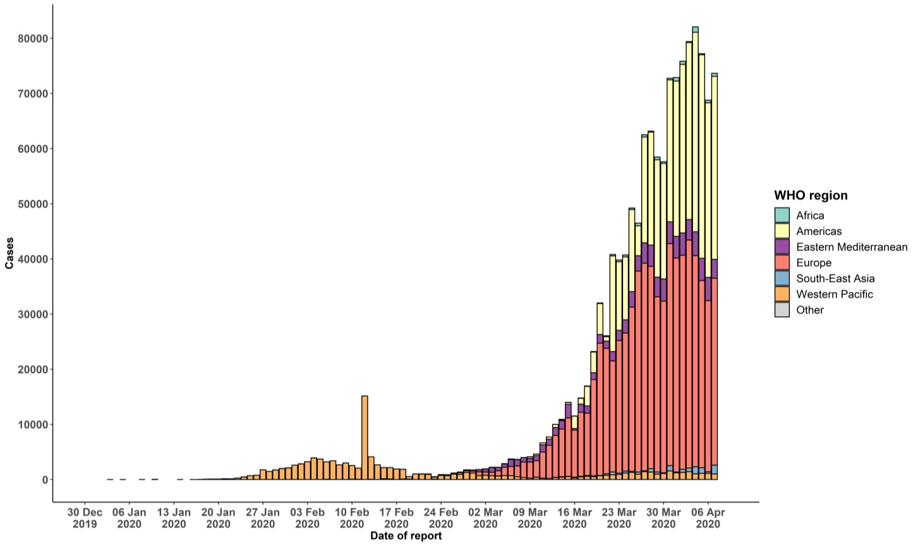

STRATEGIC OBJECTIVES

WHO’s strategic objectives for this response are to:

  - Interrupt human-to-human transmission including reducing secondary infections among close contacts and health care workers, preventing transmission amplification events, and preventing further international spread*;
  - Identify, isolate and care for patients early, including providing optimized care for infected patients;
  - Identify and reduce transmission from the animal source;
  - Address crucial unknowns regarding clinical severity, extent of transmission and infection, treatment options, and accelerate the development of diagnostics, therapeutics and vaccines;
  - Communicate critical risk and event information to all communities and counter misinformation;
  - Minimize social and economic impact through multisectoral partnerships.

*This can be achieved through a combination of public health measures, such as rapid identification, diagnosis and management of the cases, identification and follow up of the contacts, infection prevention and control in health care settings, implementation of health measures for travelers, awareness-raising in the population and risk communication.
PREPAREDNESS AND RESPONSE
- To view all technical guidance documents regarding COVID-19, please go to this webpage.
- WHO has developed interim guidance for laboratory diagnosis, advice on the use of masks during home care and in health care settings in the context of the novel coronavirus (2019-nCoV) outbreak, clinical management, infection prevention and control in health care settings, home care for patients with suspected novel coronavirus, risk communication and community engagement and Global Surveillance for human infection with novel coronavirus (2019-nCoV).
- WHO is working closely with International Air Transport Association (IATA) and have jointly developed a guidance document to provide advice to cabin crew and airport workers, based on country queries. The guidance can be found on the IATA webpage.
- WHO has been in regular and direct contact with Member States where cases have been reported. WHO is also informing other countries about the situation and providing support as requested.
- WHO is working with its networks of researchers and other experts to coordinate global work on surveillance, epidemiology, mathematical modelling, diagnostics and virology, clinical care and treatment, infection prevention and control, and risk communication. WHO has issued interim guidance for countries, which are updated regularly.
- WHO has prepared a disease commodity package that includes an essential list of biomedical equipment, medicines and supplies necessary to care for patients with 2019-nCoV.
- WHO has provided recommendations to reduce risk of transmission from animals to humans.
- WHO has published an updated advice for international traffic in relation to the outbreak of the novel coronavirus 2019-nCoV.
- WHO has activated the R&D blueprint to accelerate diagnostics, vaccines, and therapeutics.
- OpenWHO is an interactive, web-based, knowledge-transfer platform offering online courses to improve the response to health emergencies. COVID-19 courses can be found here and courses in additional national languages here. Specifically, WHO has developed online courses on the following topics:
  - A general introduction to emerging respiratory viruses, including novel coronaviruses (available in Arabic, Chinese, English, French, Russian, Spanish, Hindi, Indian Sign Language, Persian, Portuguese, Serbian and Turkish);
  - Clinical care for Severe Acute Respiratory Infections (available in English, French, Russian, Indonesian and Vietnamese);
  - Health and safety briefing for respiratory diseases - ePROTECT (available in Chinese, English, French, Russian, Spanish, Indonesian and Portuguese);
  - Infection Prevention and Control for Novel Coronavirus (COVID-19) (available in Chinese, English, French,
Russian, Spanish, Indonesian, Italian, Japanese, Portuguese and Serbian); and
  - COVID-19 Operational Planning Guidelines and COVID-19 Partners Platform to support country preparedness and response (available in English and coming soon in additional languages).
- WHO is providing guidance on early investigations, which are critical in an outbreak of a new virus. The data collected from the protocols can be used to refine recommendations for surveillance and case definitions, to characterize the key epidemiological transmission features of COVID-19, help understand spread, severity, spectrum of disease, impact on the community and to inform operational models for implementation of countermeasures such as case isolation, contact tracing and isolation. Several protocols are available here. One such protocol is for the investigation of early COVID-19 cases and contacts (the “First Few X (FFX) Cases and contact investigation protocol for 2019-novel coronavirus (2019-nCoV) infection”). The protocol is designed to gain an early understanding of the key clinical, epidemiological and virological characteristics of the first cases of COVID-19 infection detected in any individual country, to inform the development and updating of public health guidance to manage cases and reduce the potential spread and impact of infection.
RECOMMENDATIONS AND ADVICE FOR THE PUBLIC

If you are not in an area where COVID-19 is spreading or have not travelled from an area where COVID-19 is spreading or have not been in contact with an infected patient, your risk of infection is low. It is understandable that you may feel anxious about the outbreak. Get the facts from reliable sources to help you accurately determine your risks so that you can take reasonable precautions (see Frequently Asked Questions). Seek guidance from WHO, your healthcare provider, your national public health authority or your employer for accurate information on COVID-19 and whether COVID-19 is circulating where you live. It is important to be informed of the situation and take appropriate measures to protect yourself and your family (see Protection measures for everyone).

If you are in an area where there are cases of COVID-19 you need to take the risk of infection seriously. Follow the advice of WHO and guidance issued by national and local health authorities. For most people, COVID-19 infection will cause mild illness however, it can make some people very ill and, in some people, it can be fatal. Older people, and those with pre-existing medical conditions (such as cardiovascular disease, chronic respiratory disease or diabetes) are at risk for severe disease (See Protection measures for persons who are in or have recently visited (past 14 days) areas where COVID-19 is spreading).

CASE DEFINITIONS

WHO periodically updates the Global Surveillance for human infection with coronavirus disease (COVID-19) document which includes case definitions.

For easy reference, case definitions are included below.

Suspect case
- A patient with acute respiratory illness (fever and at least one sign/symptom of respiratory disease, e.g., cough, shortness of breath), AND a history of travel to or residence in a location reporting community transmission of COVID-19 disease during the 14 days prior to symptom onset.
OR
- A patient with any acute respiratory illness AND having been in contact with a confirmed or probable COVID-19 case (see definition of contact) in the last 14 days prior to symptom onset;
OR
- A patient with severe acute respiratory illness (fever and at least one sign/symptom of respiratory disease, e.g., cough, shortness of breath; AND requiring hospitalization) AND in the absence of an alternative diagnosis that fully explains the clinical presentation.

Probable case
- A suspect case for whom testing for the COVID-19 virus is inconclusive.
  - Inconclusive being the result of the test reported by the laboratory.
OR
- A suspect case for whom testing could not be performed for any reason.

Confirmed case
A person with laboratory confirmation of COVID-19 infection, irrespective of clinical signs and symptoms.
- Technical guidance for laboratory testing can be found here.

Definition of contact
A contact is a person who experienced any one of the following exposures during the 2 days before and the 14 days
after the onset of symptoms of a probable or confirmed case:
- Face-to-face contact with a probable or confirmed case within 1 meter and for more than 15 minutes;
- Direct physical contact with a probable or confirmed case;
- Direct care for a patient with probable or confirmed COVID-19 disease without using proper personal protective equipment1; OR
- Other situations as indicated by local risk assessments.

Note: for confirmed asymptomatic cases, the period of contact is measured as the 2 days before through the 14 days
after the date on which the sample was taken which led to confirmation.

1 World Health Organization. Infection prevention and control during health care when COVID-19 is suspected https://www.who.int/publications-detail/infection-prevention-and-control-during-health-care-when-novel-coronavirus-(ncov)- infection-is-suspected-20200125

